2 Problems of Computer Vision:

1. Object Detection
   1. If we have multiple objects within an image, like cat and dog in a pic, we might need to find their location, so we will try drawing rectangular bounding boxes
   2. 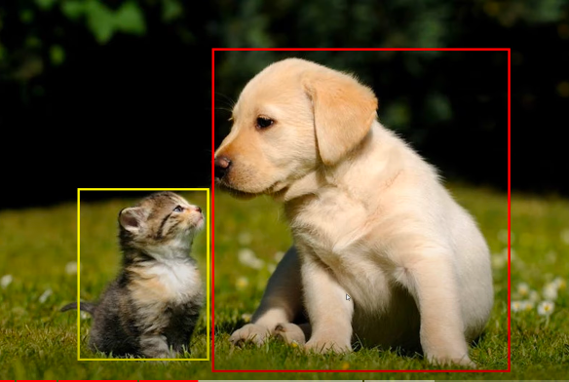
   3. And this is called object detection, where we try to detect objects within a image
   4. We can go one more level up and classify each pixel for example in the below image all red pixels are dogs and all yellow pixels are cats, this is more fine grained classification
   5. 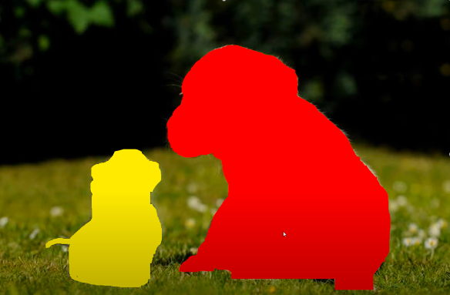
2. Image Classification
   1. Classifying entire image into a class
   2. Image Classification on with localization
      1. Along with classifying the image, we also find it’s location within the image
   3. If we have multiple images

